**WEEK-6**

**ReactJS-HOL**

**Exercise 1:**

**App.js**

import React from 'react';

function App() {

  return (

    <div>

      <h1>Welcome to the first session of React</h1>

    </div>

  );

}

export default App;

**Output:**

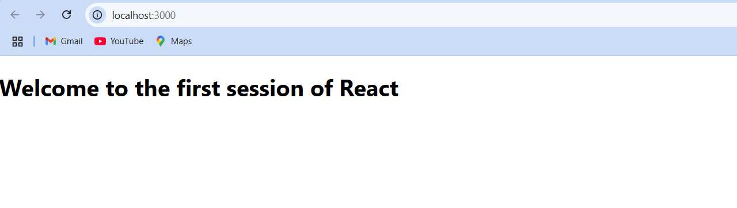

**Exercise 2:**

**Src-> Components**

**->Home.js**

import React, { Component } from 'react';

class Home extends Component {

  render() {

    return (

      <div>

        <h3>Welcome to the Home Page of Student Management Portal</h3>

      </div>

    );

  }

}

export default Home;

**->About.js**

import React, { Component } from 'react';

class About extends Component {

  render() {

    return (

      <div>

        <h3>Welcome to the About Page of Student Management Portal</h3>

      </div>

    );

  }

}

export default About;

**->Contact.js**

import React, { Component } from 'react';

class Contact extends Component {

  render() {

    return (

      <div>

        <h3>Welcome to the Contact Page of Student Management Portal</h3>

      </div>

    );

  }

}

export default Contact;

**->App.js**

import React from 'react';

import './App.css';

import Home from './Components/Home';

import About from './Components/About';

import Contact from './Components/Contact';

function App() {

  return (

    <div className="App">

      <Home />

      <About />

      <Contact />

    </div>

  );

}

export default App;

**Output:**

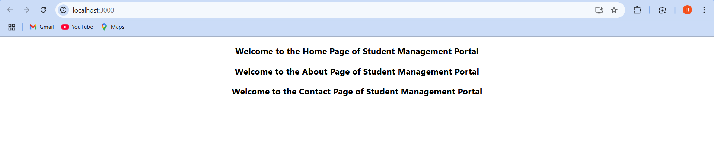

**Exercise 3:**

**Src->Componenets**

**->CalculateScore.js**

import React from 'react';

import '../Stylesheets/mystyle.css';

const percentToDecimal = (decimal) => {

  return (decimal * 100).toFixed(2) + '%';

};

const calcScore = (total, goal) => {

  return percentToDecimal(total / goal);

};

export const CalculateScore = ({ Name, School, total, goal }) => {

  return (

    <div className="formatstyle">

      <h1><font color="Brown">Student Details:</font></h1>

      <div className="Name">

        <b><span>Name: </span></b>

        <span>{Name}</span>

      </div>

      <div className="School">

        <b><span>School: </span></b>

        <span>{School}</span>

      </div>

      <div className="Total">

        <b><span>Total: </span></b>

        <span>{total}</span>

        <span> Marks</span>

      </div>

      <div className="Score">

        <b>Score: </b>

        <span>{calcScore(total, goal)}</span>

      </div>

    </div>

  );

};

**->Stylesheets**

**->mystyle.css**

.Name {

  font-weight: 300;

  color: blue;

}

.School {

  color: crimson;

}

.Total {

  color: darkmagenta;

}

.formatstyle {

  text-align: center;

  font-size: large;

  padding: 20px;

  border: 2px solid teal;

  margin: 30px auto;

  width: 50%;

  background-color: #f5faff;

  border-radius: 10px;

  box-shadow: 2px 2px 10px rgba(0, 128, 128, 0.1);

}

.Score {

  color: forestgreen;

  margin-top: 10px;

}

**->App.js**

import React from 'react';

import './App.css';

import { CalculateScore } from './Components/CalculateScore';

function App() {

  return (

    <div className="App">

      <CalculateScore

        Name="Harish.S"

        School="Everwin Matriculation Higher Secondary School"

        total={462}

        goal={500}

      />

    </div>

  );

}

export default App;

**Output:**

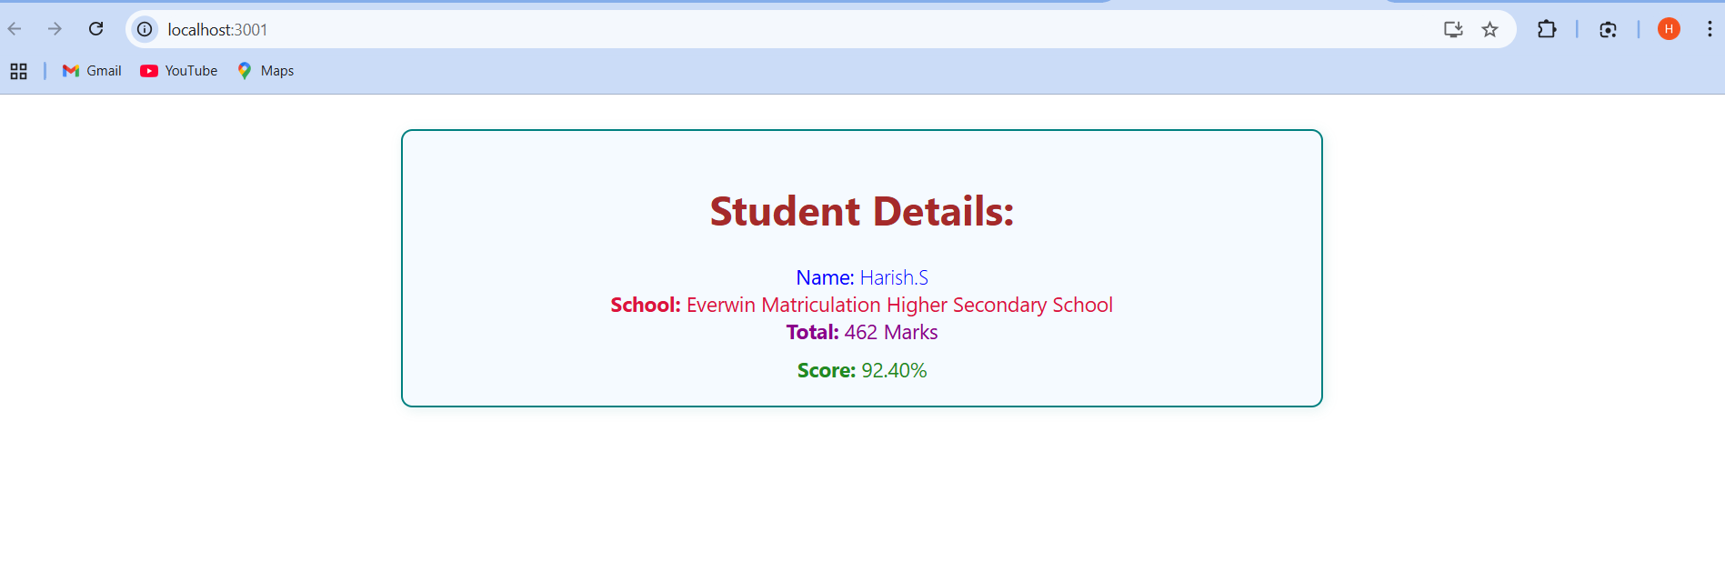

**Exercise 4:**

**Post.js**

class Post {

  constructor(userId, id, title, body) {

    this.userId = userId;

    this.id = id;

    this.title = title;

    this.body = body;

  }

}

export default Post;

**Posts.js**

import React, { Component } from "react";

import Post from "./Post";

class Posts extends Component {

  constructor(props) {

    super(props);

    this.state = {

      posts: [],

    };

  }

**// Step 6: Load Posts using Fetch API**

  loadPosts = () => {

    fetch("https://jsonplaceholder.typicode.com/posts")

      .then((response) => response.json())

      .then((data) => {

        const postObjects = data.map(

          (post) => new Post(post.userId, post.id, post.title, post.body)

        );

        this.setState({ posts: postObjects });

      })

      .catch((error) => {

        throw error; // Will be caught by componentDidCatch

      });

  };

**// Step 7: Call loadPosts when component mounts**

  componentDidMount() {

    this.loadPosts();

  }

**// Step 9: Handle any rendering errors**

  componentDidCatch(error, info) {

    alert("An error occurred: " + error);

  }

**// Step 8: Render the Posts**

  render() {

    return (

      <div>

        <h1>Blog Posts</h1>

        {this.state.posts.map((post) => (

          <div key={post.id} style={{ border: "1px solid gray", margin: "10px", padding: "10px" }}>

            <h3>{post.title}</h3>

            <p>{post.body}</p>

          </div>

        ))}

      </div>

    );

  }

}

export default Posts;

**App.js**

import React from "react";

import "./App.css";

import Posts from "./Posts";

function App() {

  return (

    <div className="App">

      <Posts />

    </div>

  );

}

export default App;

**Output:**

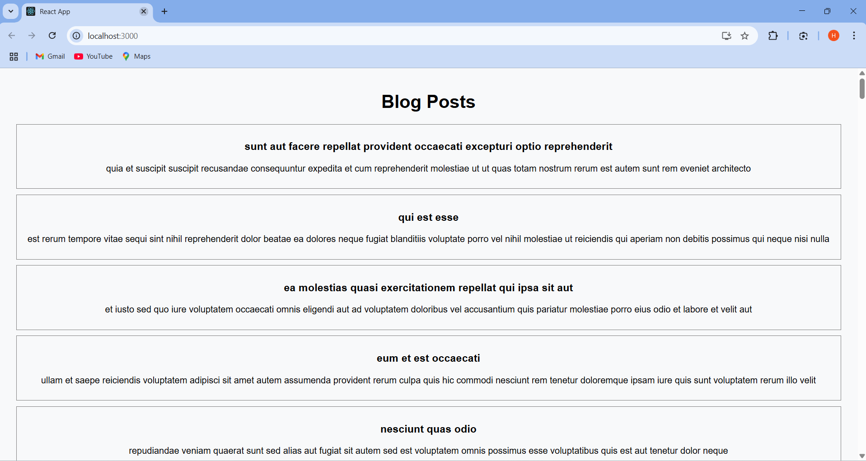

**Exercise:5**

**CohortDetails.js**

import React from 'react';

import styles from './CohortDetails.module.css';

function CohortDetails({ cohort }) {

  const headingStyle = {

    color:

      cohort.status.toLowerCase() === 'ongoing'

        ? 'green'

        : 'blue', // Scheduled = blue

  };

  return (

    <div className={styles.box}>

      <h3 style={headingStyle}>{cohort.name}</h3>

      <dl>

        <dt>Started On</dt>

        <dd>{cohort.startDate}</dd>

        <dt>Current Status</dt>

        <dd>{cohort.status}</dd>

        <dt>Coach</dt>

        <dd>{cohort.coach}</dd>

        <dt>Trainer</dt>

        <dd>{cohort.trainer}</dd>

      </dl>

    </div>

  );

}

export default CohortDetails;

**CohortDetails.module.css**

.box {

  width: 300px;

  display: inline-block;

  margin: 10px;

  padding: 10px 20px;

  border: 1px solid #ccc;

  border-radius: 10px;

  vertical-align: top;

  box-shadow: 1px 1px 3px rgba(0, 0, 0, 0.1);

}

dt {

  font-weight: 500;

}

dd {

  margin: 0 0 10px 0;

}

**App.js**

import React from 'react';

import CohortDetails from './components/CohortDetails';

function App() {

  const cohorts = [

    {

      name: 'INTADMDF10 - .NET FSD',

      startDate: '22-Feb-2022',

      status: 'Scheduled',

      coach: 'Aathma',

      trainer: 'Jojo Jose',

    },

    {

      name: 'ADM21JF014 - Java FSD',

      startDate: '10-Sep-2021',

      status: 'Ongoing',

      coach: 'Apoorv',

      trainer: 'Elisa Smith',

    },

    {

      name: 'CDBJF21025 - Java FSD',

      startDate: '24-Dec-2021',

      status: 'Ongoing',

      coach: 'Aathma',

      trainer: 'John Doe',

    },

  ];

  return (

    <div style={{ padding: '20px' }}>

      <h2>Cohorts Details</h2>

      {cohorts.map((cohort, index) => (

        <CohortDetails key={index} cohort={cohort} />

      ))}

    </div>

  );

}

export default App;

**Output:**

